PRESS CONFERENCE 29 MARCH 2017

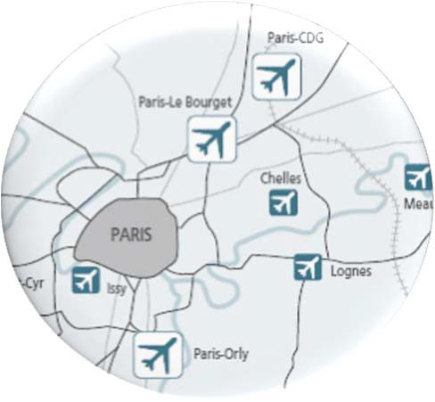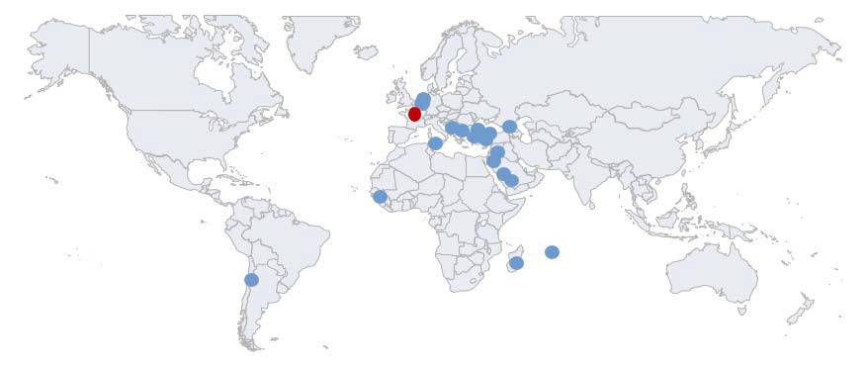

GROUPE ADP IS...

- An airport system comprising three airports in France: Paris-Charles de Gaulle/Paris-Orly/Paris-Le Bourget
- 23 airports managed worldwide
- 240 million passengers handled in 2016
- three strategic priorities: Optimise, Attract and Expand

- €4.6 billion in investments between 2016 and 2020

GROUPE ADP - 29/03/2017 - INNOVATION HUB PAGE 2

AN EXCEPTIONAL AREA

Example: Paris-Charles de Gaulle Airport

- 3,257 hectares
- 180,000 passengers per day
- 90,000 employees per day
- 5 metro stations - driverless line
- 300,000 trips per day

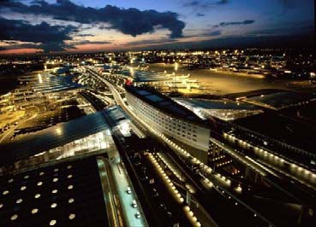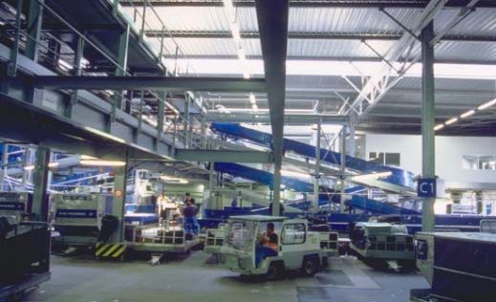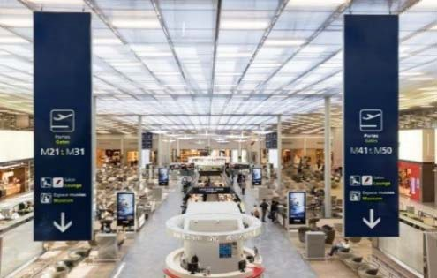
Smart City Smart Building

Smart factory

GROUPE ADP - 29/03/2017 - INNOVATION HUB PAGE 3

EXAMPLES OF PROJECTS ROLLED OUT

Arrivals Information spaces
Reading areas Security checkpoint waiting times

Vasco Biop
Prima Mobile app
Business Areas

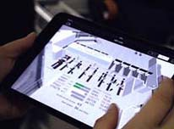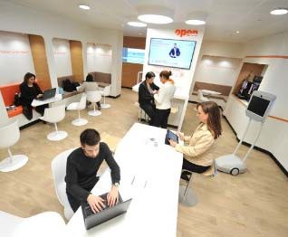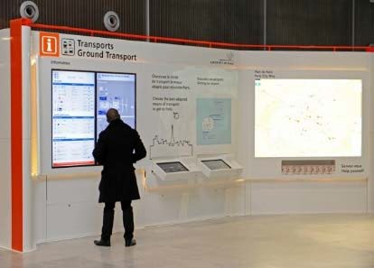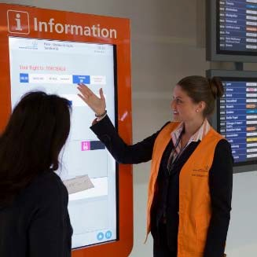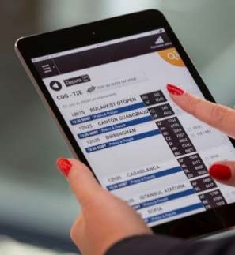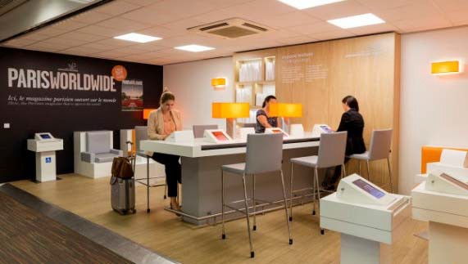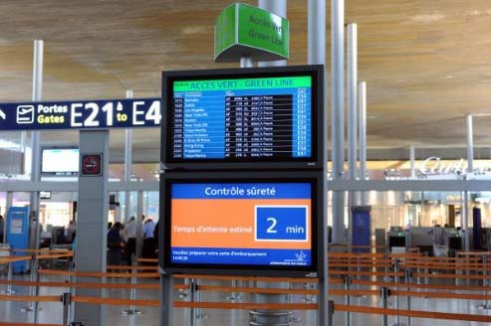

GROUPE ADP - 29/03/2017 - INNOVATION HUB PAGE 4

OUR AMBITION:
TO BECOME THE MOST INNOVATIVE AIRPORT GROUP IN THE WORLD

- Roll out the Innovation Hub approach on an international scale

- Speed up the development of innovation ecosystems in spaces that embody this approach

- Develop a truly innovative range of services throughout the value chain

GROUPE ADP - 29/03/2017 - INNOVATION HUB PAGE 5

Our goals:
INNOVATION AS A DRIVER OF TRANSFORMATION AND COMPETITIVENESS

- Speed up innovation with prototypes and trialling in the short term
- Explore new areas and business models in the medium term
- Spread the innovation culture and involve employees in the approach
- Provide assistance for business units (sourcing, methodology, financing)

Customer perception:
- Passengers (B2C)
- Airlines (B2B)
- Employees (B2E)

A unique organisation which:
- evolves in short cycle decision-making(Test & Learn culture)
- has a state-of-the-art system
- is free to take the initiative
- has its own budget

GROUPE ADP - 29/03/2017 - INNOVATION HUB PAGE 6

THREE STRATEGIC VERTICALS

SMART AIRPORT
- Develop smart infrastructure, a digital airport
- Boost the personalised service offering, in order to provide a unique experience

BETTER CONNECTIONS
- Improve connectivity with new digital and automation options
- Optimise links between the city and the airport, and travel throughout the airport

ROBOTICS
- Implement process automation solutions to meet the needs of the business lines
- Rethink the passenger experience through the use of new technologies

GROUPE ADP - 29/03/2017 - INNOVATION HUB PAGE 7

INNOVATION HUB: A SYSTEMIC APPROACH

Trial
Build an industrial partnership

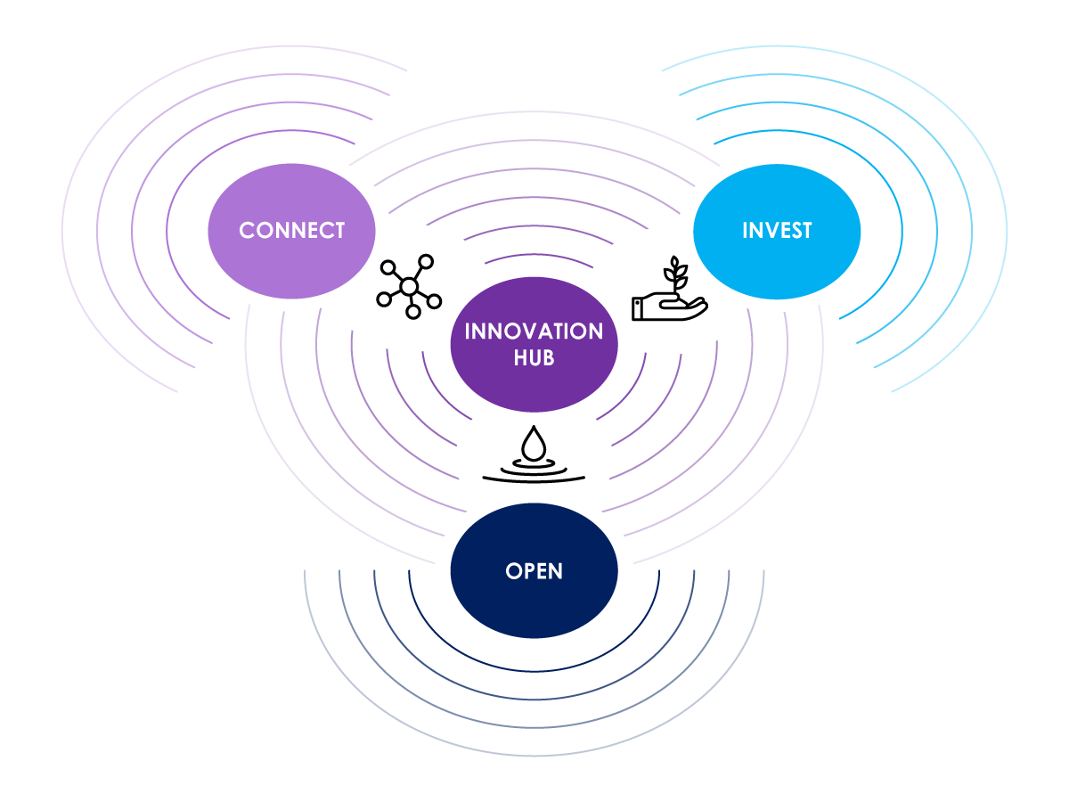

Enhance the ecosystem

GROUPE ADP - 29/03/2017 - INNOVATION HUB PAGE 8

01

OPEN

OPEN, IDENTIFY, TRANSFORM

GROUPE ADP - 29/03/2017 - INNOVATION HUB PAGE 9

A UNIQUE ECOSYSTEM

INCUBATORS
EVENTS

INSTITUTIONS

FINANCING AIRPORTS

COMPETITIVE
CLUSTERS ACADEMIC INSTITUTIONS
PARTNERS/ KEY ACCOUNTS

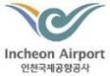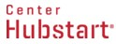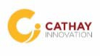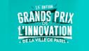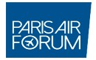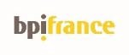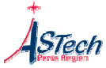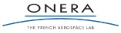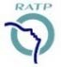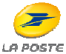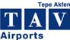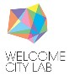

GROUPE ADP - 29/03/2017 - INNOVATION HUB PAGE 10

SERVING THE DISSEMINATION OF THE CULTURE OF INNOVATION

"Hello Tomorrow"
The Plane of Tomorrow conference ("L’avion du futur")
Immersion/ prototype meeting

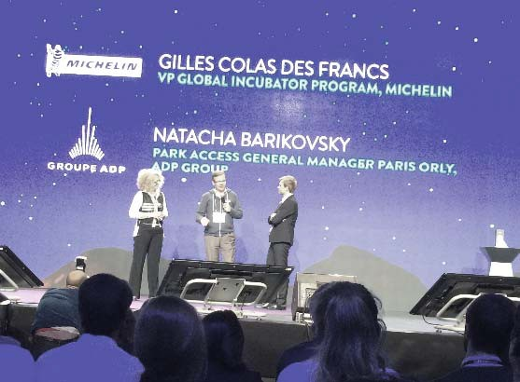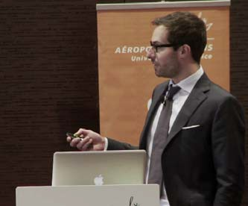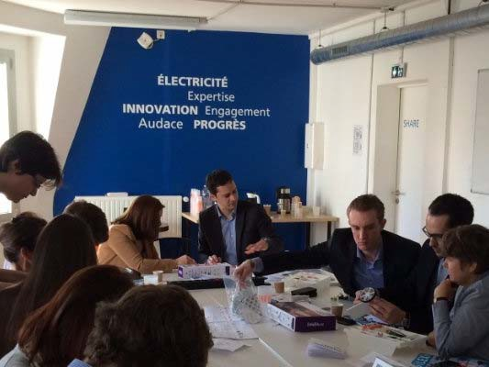

APRIL/MAY

A few Innovation Hub events
Innovation Day with Schiphol and Incheon
Groupe ADP/Air France Intrapreneurship Conference
Cybersecurity exercise with EPITECH

GROUPE ADP - 29/03/2017 - INNOVATION HUB PAGE 11

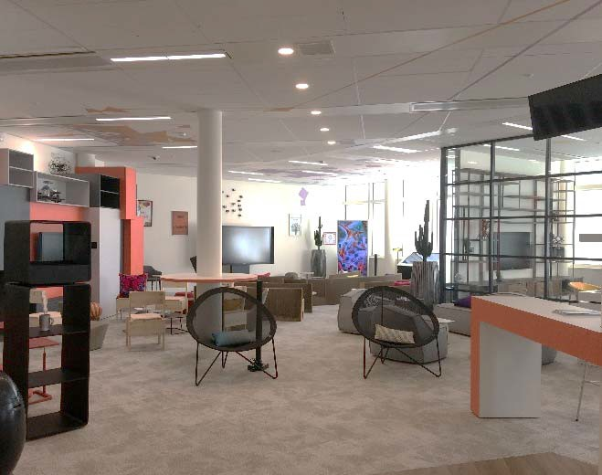

A DEDICATED SPACE AT THE GROUPE ADP HEAD OFFICE

Three functions:

  - A technological showroom space
  - A venue to welcome visitors and host events
  - An offering to support experimental projects

GROUPE ADP - 29/03/2017 - INNOVATION HUB PAGE 12

02

CONNECT

GET ONBOARD, TRIAL, ROLL OUT

GROUPE ADP - 29/03/2017 - INNOVATION HUB PAGE 13

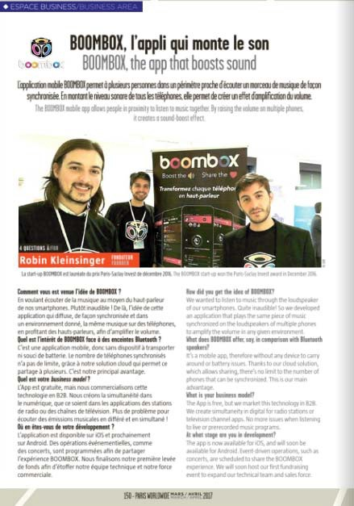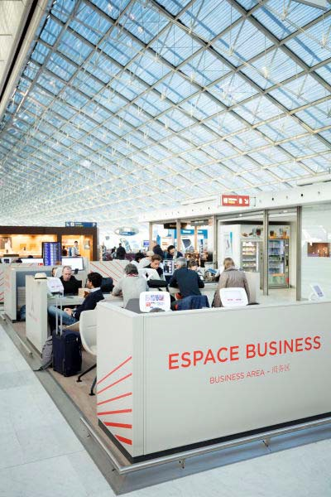

VISIBILITY FOR START-UPS

- Three Business Areas at Paris–Charles de Gaulle and two at Paris-Orly
- Over a hundred start-up pitches
- Partnership with OpenSkies: "Pitch on the plane"
- Presentation of start-ups in PARIS WORLDWIDE magazine (300,000 copies)

GROUPE ADP - 29/03/2017 - INNOVATION HUB PAGE 14

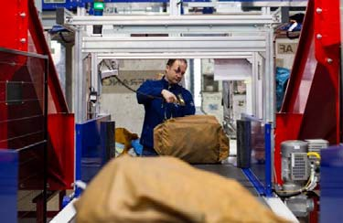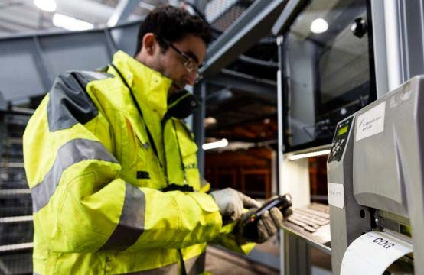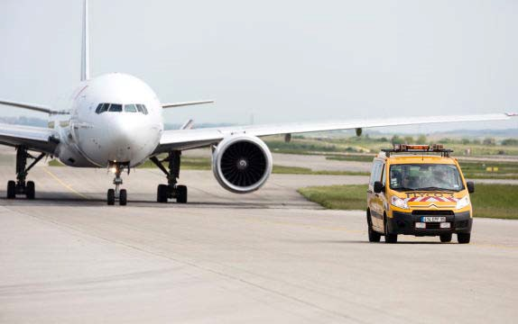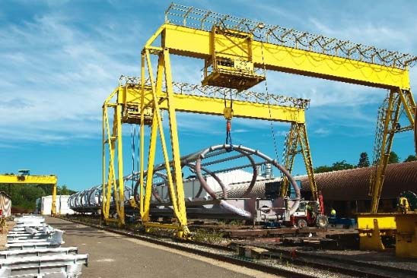

EXPERTISE AND MENTORING TO SERVE ENTREPRENEURS

- A diversity of know-how (Operations, Engineering, Maintenance, Aeronautics, IT, etc.)

- Trialling monitored by a business advisor

GROUPE ADP - 29/03/2017 - INNOVATION HUB PAGE 15

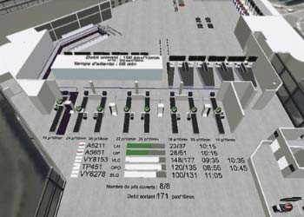

PROJECTS DEVELOPED

'Airport in your pocket' – Vasco Tristan Kiefer – Business Developer

  - Tool for managing terminal operations on-the-go
    - 3D real-time information on passenger flows
- Staffing and equipment adjusted to fit the situation

GROUPE ADP - 29/03/2017 - INNOVATION HUB PAGE 16

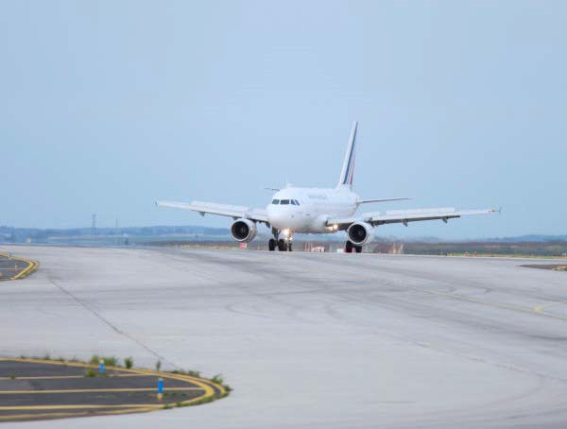

PROJECTS DEVELOPED

Big Data for aeronautics

Pierre Journaux - CEO

- Products to improve airline and airport operations
- AirsideWatch: Optimise runway operations with radar data
  - Technology based on machine learning algorithms

GROUPE ADP - 29/03/2017 - INNOVATION HUB PAGE 17

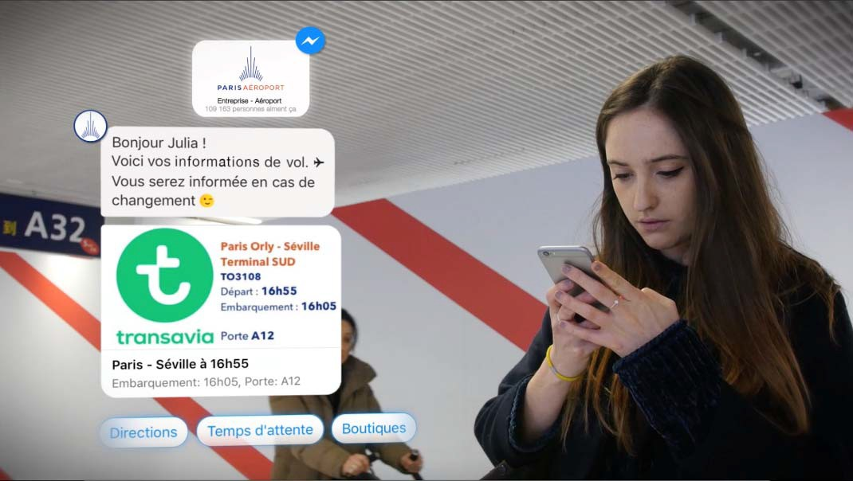

PROJECTS UNDER WAY

Personalised assistance for customers

Guillaume Laporte– Co-founder

    - A travel bot with artificial intelligence
- Door-to-door assistance for passengers
- Technology that can interface with multiple data sources

GROUPE ADP - 29/03/2017 - INNOVATION HUB PAGE 18

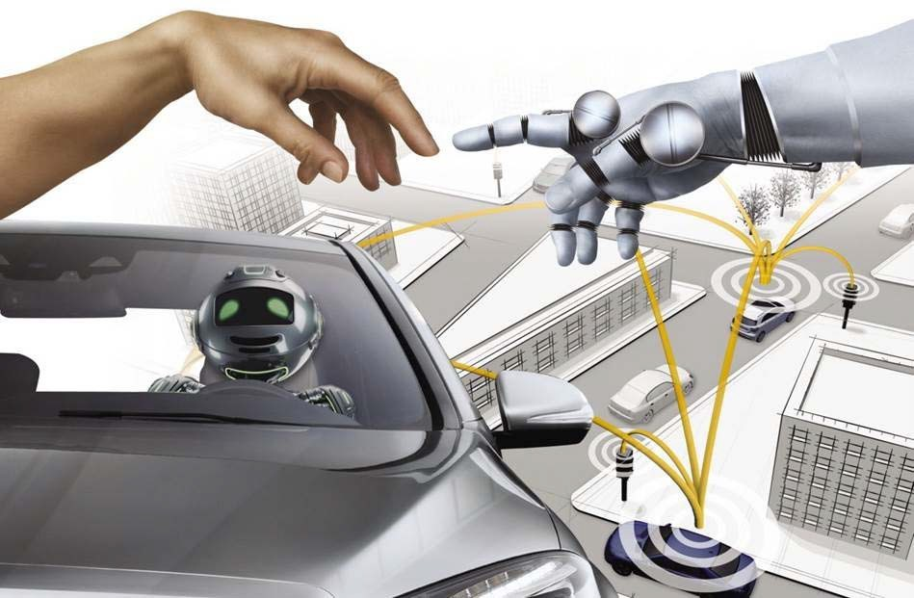

PROJECTS UNDER WAY

Maximum connectivity - Driverless vehicles

  - A pilot project for group employees
  - A route that includes an intersection
    - Roll-out scheduled for end-2017

GROUPE ADP - 29/03/2017 - INNOVATION HUB PAGE 19

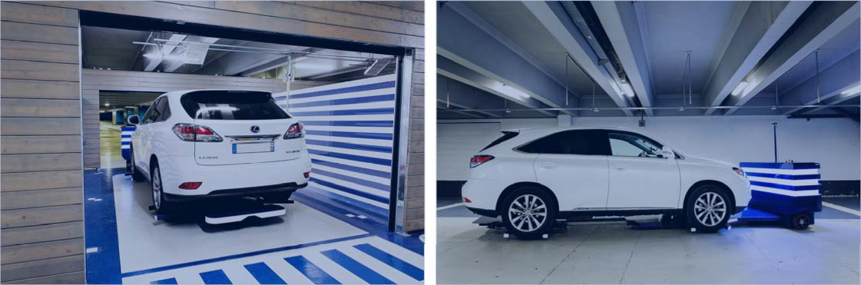

PROJECTS DEVELOPED WITH START-UPS

Parking made easy

Clément Boussard - CEO

      - A robot that parks your car
- A time-saver when arriving and leaving the airport
  - Parking capacity optimised by up to 50%

GROUPE ADP - 29/03/2017 - INNOVATION HUB PAGE 20

03

INVEST

GET INVOLVED, HELP, DEVELOP

GROUPE ADP - 29/03/2017 - INNOVATION HUB PAGE 21

INVESTMENT: A NEW INNOVATION DRIVER

A dual approach

ADP Invest
- Dedicated to strategic operations

- Budget of €16m over five years
Outside funds
- Qualified expertise and sourcing

- Geographic diversity

- Co-investment capacity

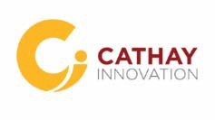

GROUPE ADP - 29/03/2017 - INNOVATION HUB PAGE 22

ADP INVEST: AN IN-HOUSE INVESTMENT FUND

An investment vehicle dedicated to strategic operations

- A dedicated team

Target companies: Start-ups (initial fundraising)
Area: Smart infrastructure, robotics, mobility and more

Development phase: marketable product
Prerequisite: Trialling completed or under way with Groupe ADP
Investment level: minority shareholder
Investment criteria: Team, technology, market

Co-development and partnership approach with start-ups over the long term

GROUPE ADP - 29/03/2017 - INNOVATION HUB PAGE 23

THREE COMPLEMENTARY OUTSIDE FUNDS

- Funds in different geographic regions

- Start-ups at varying stages of development

- Investment areas that are consistent with our strategic challenges

- Partnerships to further the group's strategy abroad

- Resources that make it possible to draw on global expertise and monitoring

- Opportunities for co-investment with the in-house fund

(Discussions underway)

GROUPE ADP - 29/03/2017 - INNOVATION HUB PAGE 24

OPEN/CONNECT/INVEST IMAGINE THE AIRPORT OF THE FUTURE

Come and discover by the end of 2017, the futuristic passenger experience as dreamed up by the "Play Your Airport" community

GROUPE ADP - 29/03/2017 - INNOVATION HUB PAGE 25

PLAY YOUR AIRPORT
THE BIGGEST GLOBAL AIRPORT CHALLENGE

  - A contest to imagine and develop the airport of the future
  - An exercise in collective intelligence
  - A driver for intrapreneurship
  - From May to November 2017 General public

Start-up

Students
Employees

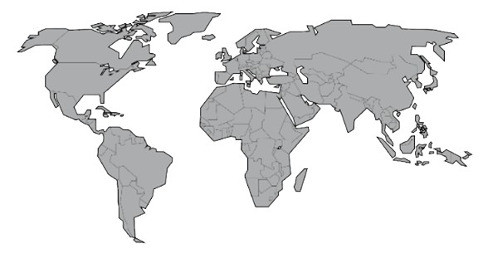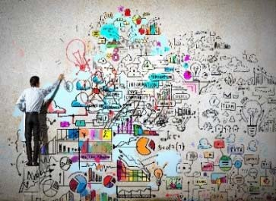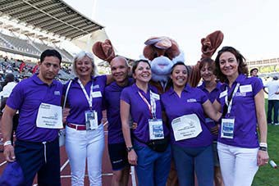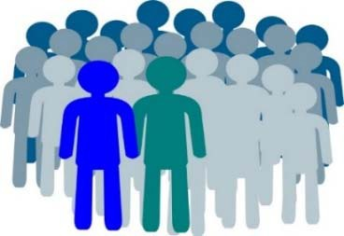
GROUPE ADP - 29/03/2017 - INNOVATION HUB PAGE 26

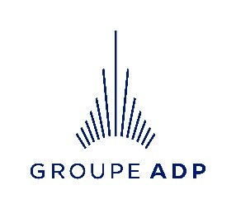

http://www.parisaeroport.fr/groupe/innovation

GROUPE ADP - 29/03/2017 - INNOVATION HUB PAGE 27

